

NAME: D DEVISRI PRASAD
REG NO:192425221
COURSE CODE: MLA0214
COURSE NAME: FUNDAMENTAL OF MACHINE LEARNING

QUESTION: Write a program to implement Logistic Regression (LR) algorithm in python
AIM: To implement Logistic Regression for classification.
ALGORITHM:
- Start the program.
- Define training dataset.
- Train the Logistic Regression model.
- Provide test input.
- Predict the output class.

CODE:
from sklearn.linear_model import LogisticRegression
X = [[1],[2],[3],[6],[7],[8]]
y = [0,0,0,1,1,1]
model = LogisticRegression()
model.fit(X,y)
print("Prediction:",model.predict([[5]]))
OUTPUT:
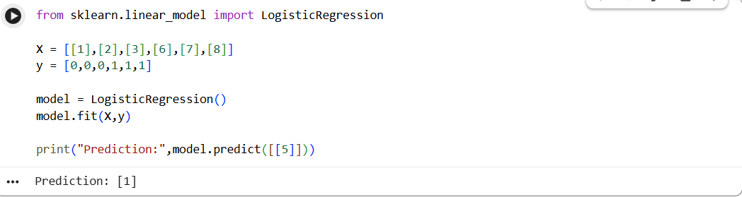
RESULT:
The Logistic Regression model successfully predicts the class of the given sample.

